NAME : **Sujan Biswas**

BATCH : BCSE 2nd Year (Lateral)

ROLL NO: 302010501003

Microprocessor lab in ASSIGNMENT #1:

1.Load the contents of the memory locations 2200H into registers .Add these register and store the results in memory location 2202 H & 2203 H.

|  |  |  |  |  |  |
| --- | --- | --- | --- | --- | --- |
| SL NO | ADDRESS | OPCODE IN HEX | LABEL | INSTRUCTIONS | COMMENTS |
| 1 | 2200 | 3A,00,22 |  | LDA 2200 | Load accumulator direct address of 2200H. |
| 2 | 2203 | 47 |  | MOV B,A | Move accumulator to b register. |
| 3 | 2204 | 3A,01,22 |  | LDA 2201 | Load accumulator direct into memory location 2201H. |
| 4 | 2207 | 0E,00 |  | MVI C,00 | Move immediate value 2200 memory address into c register. |
| 5 | 2209 | 80 |  | ADD B | Add register b with accumulator |
| 6 | 220A | D2,0E,22 |  | JNC L1 | When carry flag is 0,its jump. |
| 7 | 220D | 0C |  | INR C | Increase c ,when carry is 1. |
| 8 | 220E | 32,02,22 | L1 | STA 2202 | Store the accumulator memory address 2202H. |
| 9 | 2211 | 79 |  | MOV A,C | Move c register to accumulator |
| 10 | 2212 | 32,03,22 |  | STA 2203 | Store accumulator memory address 2203H |
| 11 | 2215 | 76 |  | HLT | Termintate the program |

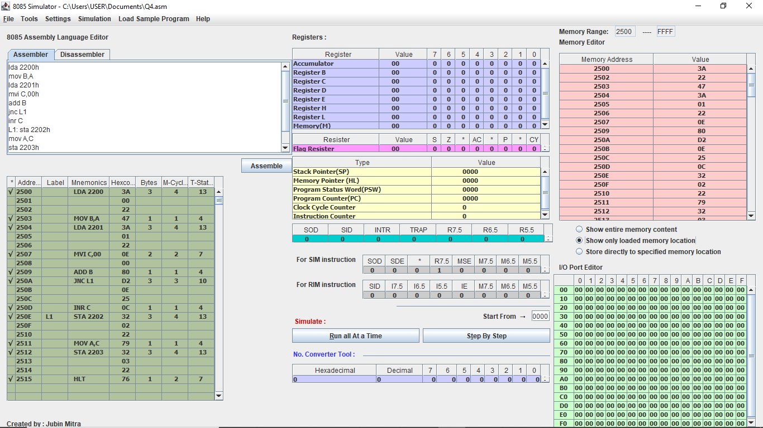

2.Find the sum of N numbers stored in consecutive locations staring from 2500 H.The value of N is stored in 2200 H. Store the results in location 2300 H and 2301 H.

|  |  |  |  |  |  |
| --- | --- | --- | --- | --- | --- |
| SL NO | ADDRESS | OPCODE IN HEX | LABEL | INSTRUCTION | COMMENTS |
| 1 | 2500 | 3A,00,22 |  | LDA 2200 | Load accumulator direct memory location 2200H . |
| 2 | 2503 | 57 |  | MOV D ,A | Move accumulator to d register. |
| 3 | 2504 | 21,00,25 |  | LXI H,2500 | Load first instruction address 2500H. |
| 4 | 2507 | 7E |  | MOV A,M | Move memory address to accumulator. |
| 5 | 2508 | 06,00 |  | MVI B,00 | Move immediate to b register. |
| 6 | 250A | 0E,00 |  | MVI C,00 | Move immediate to c register. |
| 7 | 250C | 80 | L1 | ADD B | Add b register with accumulator. |
| 8 | 250D | D2,11,25 |  | JNC L2 | Jump when carry is O. |
| 9 | 2510 | 0C |  | INRC | Increment c when carry is 1. |
| 10 | 2511 | 47 | L2 | MOV B,A | Move accumulator to b register. |
| 11 | 2512 | 23 |  | INX H | Increase HL pair. |
| 12 | 2513 | 7E |  | MOV A,M | Move memory location to accumulator. |
| 13 | 2514 | 15 |  | DCR D | Decrement d register. |
| 14 | 2515 | C2,0C,25 |  | JNZ L1 | Jump when z flag is 0. |
| 15 | 2518 | 78 |  | MOV A,B | Move b register to accumulator |
| 16 | 2519 | 32,00,23 |  | STA 2300 | Store accumulator memory location 2300 |
| 17 | 251C | 79 |  | MOV A,C | Move c register to accumulator |
| 18 | 251D | 32,01,23 |  | STA 2301 | Store accumulator memory location 2301 |
| 19 | 2520 | 76 |  | HLT | Terminate the program. |

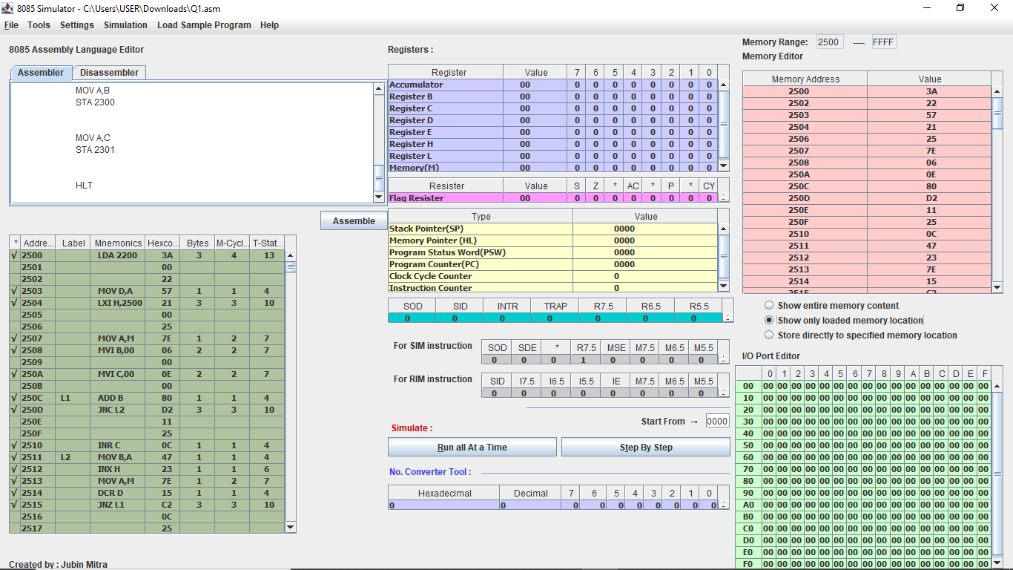

3.Find the sum of the least significant 4 bits and most significant 4 bits of a byte stored in memory location 2500H. store the result in 2550 H.

|  |  |  |  |  |  |
| --- | --- | --- | --- | --- | --- |
| SL NO | ADDRESS | OPCODE IN HEX | LABEL | INSTRUCTION | COMMENTS |
| 1 | 2500 | 21,00,25 |  | LXI H,2500H | Contents of memory location 2500H into HL register pair. |
| 2 | 2503 | 7E |  | MOV A,M | Move memory address to accumulator A=M[HL] |
| 3 | 2504 | E6,0F |  | ANI 0FH | A=A&(0000 1111) |
| 4 | 2506 | 57 |  | MOV D,A | D=A |
| 5 | 2507 | 7E |  | MOV A,M | A=M[HL] |
| 6 | 2508 | 0F |  | RRC | Rotate bits of accumulator right without carry bit |
| 7 | 2509 | 0F |  | RRC | Rotate bits of accumulator right without carry bit |
| 8 | 250A | 0F |  | RRC | Rotate bits of accumulator right without carry bit |
| 9 | 250B | 0F |  | RRC | Rotate bits of accumulator right without carry bit |
| 10 | 250C | E6,0F |  | ANI 0FH | A=A&(0000 1111) |
| 11 | 250E | 82 |  | ADD D | A=A+D |
| 12 | 250F | 32,50,25 |  | STA 2550H | Load the contents of the accumulator in the address location 2550H ,M[2550] |
| 13 | 2512 | 76 |  | HLT | Stop the program. |

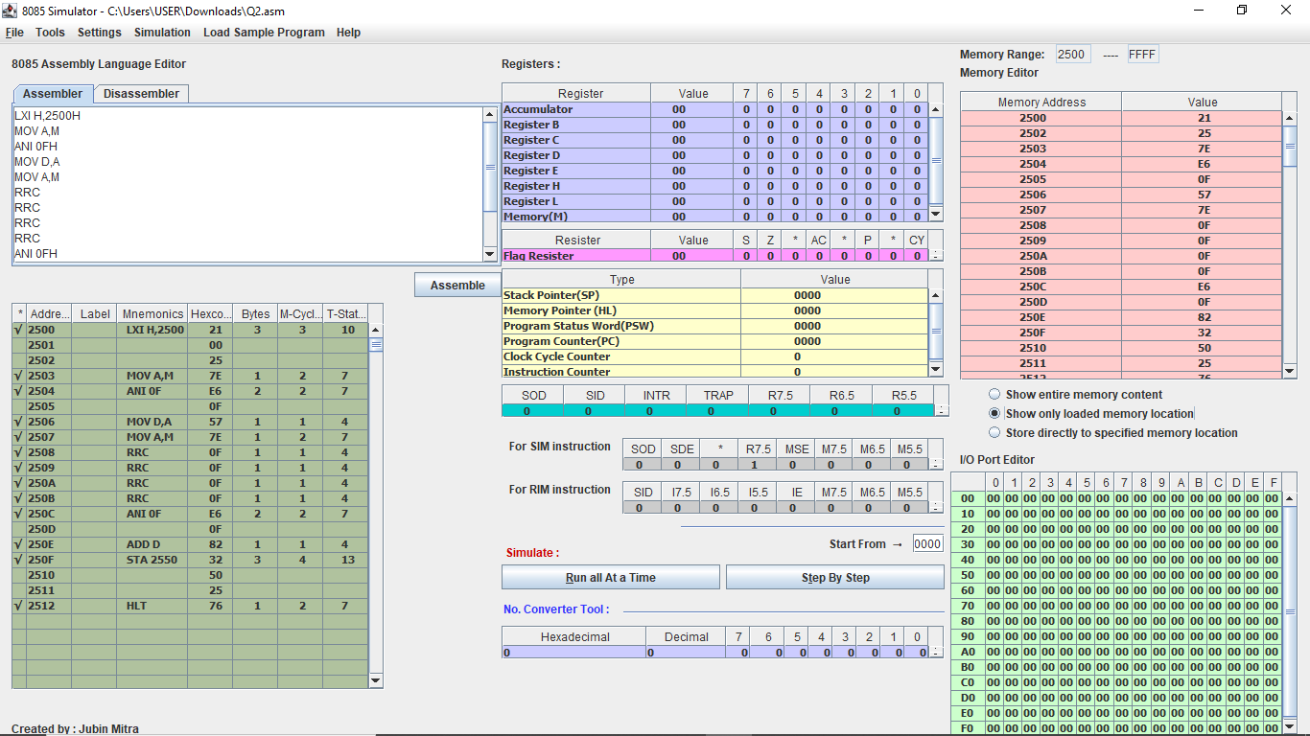

4.Write a program to count the 1’s and 0’s of a byte stored in 2500 H.Store in 2610 H,and 2511 H,respectively.

|  |  |  |  |  |  |
| --- | --- | --- | --- | --- | --- |
| SL NO | ADDRESS | OPCODE IN HEX | LABEL | INSTRUCTIONS | COMMENTS |
| 1 | 2500 | 21,00,25 |  | LXI H,2500H | Contents of memory location 2500H into HL register pair. |
| 2 | 2503 | 7E |  | MOV A,M | A=M |
| 3 | 2504 | 06,08 |  | MVI B,00H | B=08H |
| 4 | 2506 | 16,00 |  | MVI D,00H | D=00H |
| 5 | 2508 | 07 | LOOP | RLC | Rotate accumulator left without carry. |
| 6 | 2509 | D2,0D,00 |  | JNC SKIP | If no carry is generated the jump to label skip |
| 7 | 250C | 14 |  | INR D | D=D+1[To get the one count] |
| 8 | 250D | 05 | SKIP | DCR B | B=B-1 |
| 9 | 250E | C2,08,00 |  | JNZ LOOP | If contents of B is not zero then jump to the label LOOP,we need to continue this 8 times to get the count of all set bits |
| 10 | 2511 | 7A |  | MOV A,D | A=D |
| 11 | 2512 | 32,10,26 |  | STA 2610H | Load the contents of the accumulator in the address location 2610H,M[2610]=A(store the number of ones) |
| 12 | 2515 | 47 |  | MOV B,A | B=A |
| 13 | 2516 | 3E,08 |  | MVI A,08H | A=08H |
| 14 | 2518 | 90 |  | SUB B | A=A-B(To get a zero count) |
| 15 | 2519 | 32,11,25 |  | STA 2511H | Load the contents of the accumulator in the address location 2511H,M[2511]=A(store the number of ones) |
| 16 | 251C | 76 |  | HLT | Stop the program. |

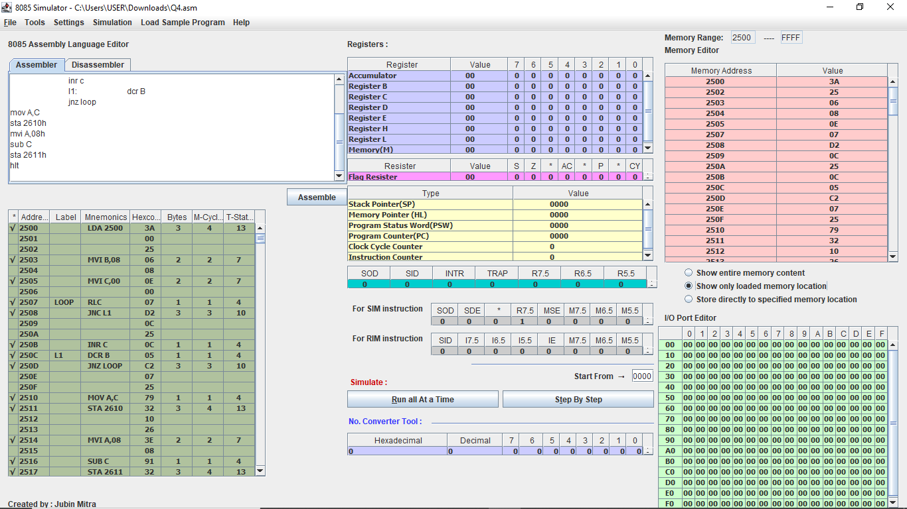

5.Write a program to sum two 16 bits binary numbers.

|  |  |  |  |  |  |
| --- | --- | --- | --- | --- | --- |
| SL NO | ADDRESS | OPCODE IN HEX | LABEL | INSTRUCTIONS | COMMENTS |
| 1 | 2500 | 21,00,25 |  | LXI H, 2500H | Contents of memory location 2500H into HL register pair |
| 2 | 2503 | 7E |  | MOV A,M | A=M[HL  ] |
| 3 | 2504 | 21,02,25 |  | LXI H,2502H | Contents of memory location 2502H into HL register pair |
| 4 | 2507 | 46 |  | MOV B,M | B=M[HL] |
| 5 | 2508 | 80 |  | ADD B | A=A+B |
| 6 | 2509 | 32,10,25 |  | STA 2510 | Load the contents of the accumulator in the address location 2510H,M[2510]=A |
| 7 | 250C | 3E,00 |  | MVI A,00H | A=00H |
| 8 | 250E | 8F |  | ADC A | Add the carry generated |
| 9 | 250F | 32,11,25 |  | STA 2511H | Load the contents of the accumulator in the address location 2511H,M[2511]=A |
| 10 | 2512 | 21,01,25 |  | LXI H,2501 | Contents of memory location 2501H into HL register pair |
| 11 | 2515 | 56 |  | MOV D,M | D=M[HL] |
| 12 | 2516 | 82 |  | ADD D | A=A+D |
| 13 | 2517 | 21,03,25 |  | LXI H,2503H | Contents of memory location 2503H into HL register pair |
| 14 | 251A | 56 |  | MOV D,M | D=M[HL] |
| 15 | 251B | 82 |  | ADD D | A=A+D |
| 16 | 251C | 32,11,25 |  | STA 2511H | Load the contents of the accumulator in the address location 2511H,M[2511]=A |
| 17 | 251F | 3E,00 |  | MVI A,00H | A=00H |
| 18 | 2521 | 8F |  | ADC A | Add the carry to the accumulator |
| 19 | 2522 | 32,12,25 |  | STA 2512H | Load the contents of the accumulator in the address location 2512H,M[2512]=A |
| 20 | 2525 | 76 |  | HLT | Stop the program |

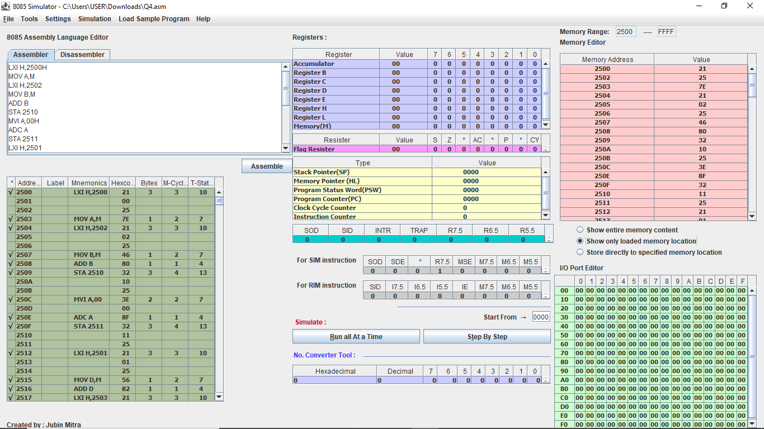

NAME : **Sujan Biswas**

BATCH: BSCE 2ND year , (LATERAL)

ROLL NO : 302010501003

Microprocessor lab Assignment problem sheet #2

1. Two numbers MNH and KLH are stored in 2050 H and 2051 H , respectively . Write a program to assemble them a NKH and LMH store them in 2052 H and 2053 H.

|  |  |  |  |  |  |
| --- | --- | --- | --- | --- | --- |
| **SL NO.** | **ADDRESS** | **OPCODE IN HEX CODE** | **LABEL** | **INSTRUCTIONS** | **COMMENTS** |
| 1 | 0000 | C3  03  00 |  | JMP START | Start the program |
| 0001 |
| 0002 |
| 2 | 0003 | 3A | START | LDA2050 H | Load accumulator direct memory location 2050 H [A=MN H] |
| 0004 | 50 |
| 0005 | 20 |
| 3 | 0006 | 07 |  | RLC | Rotate accumulator left without carry |
| 4 | 0007 | 07 |  | RLC | Rotate accumulator left without carry |
| 5 | 0008 | 07 |  | RLC | Rotate accumulator left without carry |
| 6 | 0009 | 07 |  | RLC | Rotate accumulator left without carry [After 4 rotation ,A=NM H] |
| 7 | 000A | 47 |  | MOV B,A | Move accumulator to B register [B=A=NM H] |
| 8 | 000B | 3A |  | LDA 2051 H | Load accumulator direct memory location 2051 H [A=KL H] |
| 000C | 51 |
| 000D | 20 |
| 9 | 000E | 07 |  | RLC | Rotate accumulator left without carry |
| 10 | 000F | 07 |  | RLC | Rotate accumulator left without carry |
| 11 | 0010 | 07 |  | RLC | Rotate accumulator left without carry |
| 12 | 0011 | 07 |  | RLC | Rotate accumulator left without carry [After 4 rotation, A= LK H] |
| 13 | 0012 | 4F |  | MOV C,A | Move accumulator to C register [C=A= LK H] |
| 14 | 0013 | E6 |  | ANI 0F | A=0K H |
| 0014 | 0F |
| 15 | 0015 | 57 |  | MOV D,A | Move accumulator to D register [D=A=0K H] |
| 16 | 0016 | 78 |  | MOV A,B | Move B register to accumulator [A=B=NM H] |
| 17 | 0017 | E6 |  | ANI F0 | A=N0 H |
| 0018 | F0 |
| 18 | 0019 | B2 |  | ORA D | A=N0 H|0K H=NK H |
| 19 | 001A | 32 |  | STA 2052 H | Load the contents of the accumulator in the address location 2052 H, M[2052= NK H] |
| 001B | 52 |
| 001C | 20 |
| 20 | 001D | 79 |  | MOV A,C | Move C register to accumulator [A=C=LK H] |
| 21 | 001E | E6 |  | ANI F0 | A=L0 H |
| 001F | F0 |
| 22 | 0020 | 57 |  | MOV D,A | Move accumulator to D register[A=D=L0 H] |
| 23 | 0021 | 78 |  | MOV A,B | Move B register  accumulator to[A=B=NM H] |
| 24 | 0022 | E6 |  | ANI 0F | A=0M H |
| 0023 | 0F |
| 25 | 0024 | B2 |  | ORA D | A=0M H|L0 H=LM H |
| 26 | 0025 | 32 |  | STA 2053 H | Load the contents of the accumulator in the address location 2053 H, M[2053=LM H] |
|  | 0026 | 53 |  |  |  |
| 0027 | 20 |  |
| 27 | 0028 | 76 |  | HLT | Terminate the program. |

Simulator with loaded machine code:

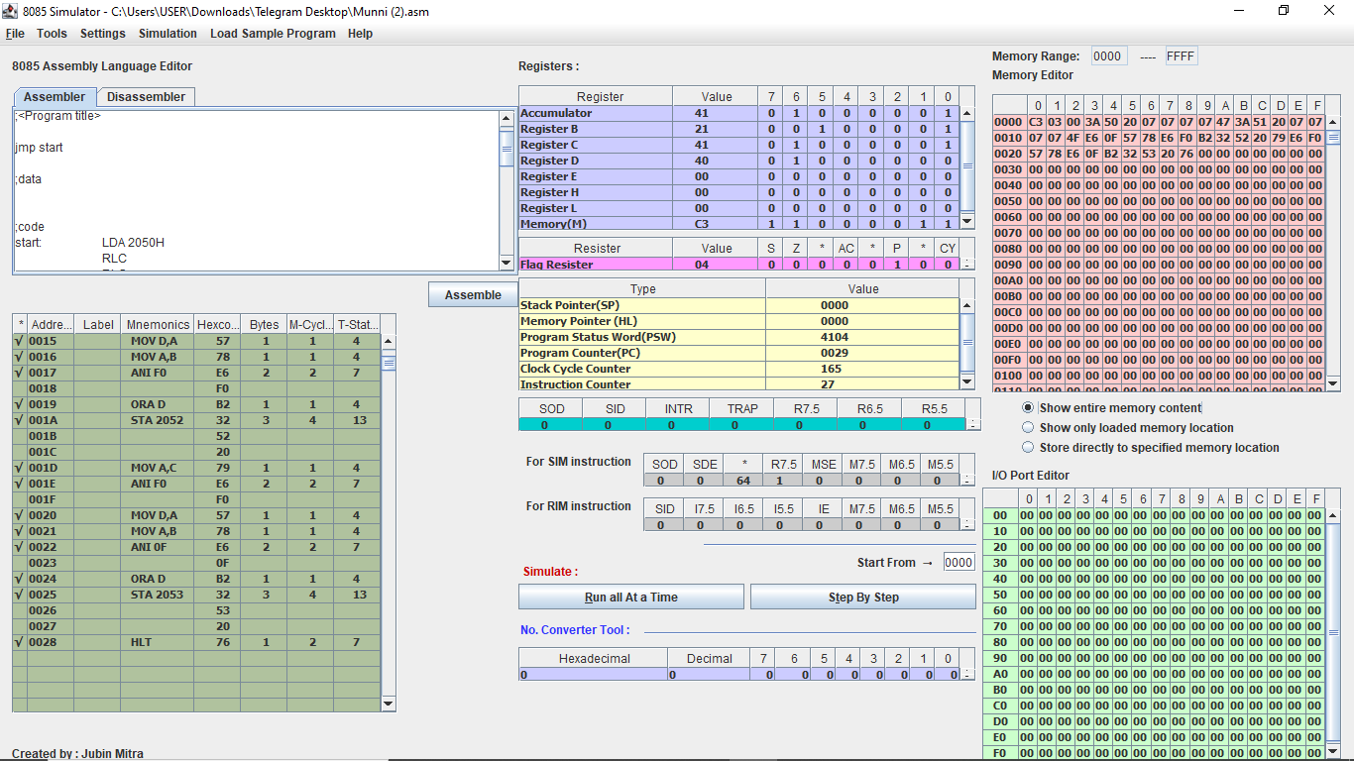

Sample input and output (M[2050 H]=12 H, M[2051 H]=14 H)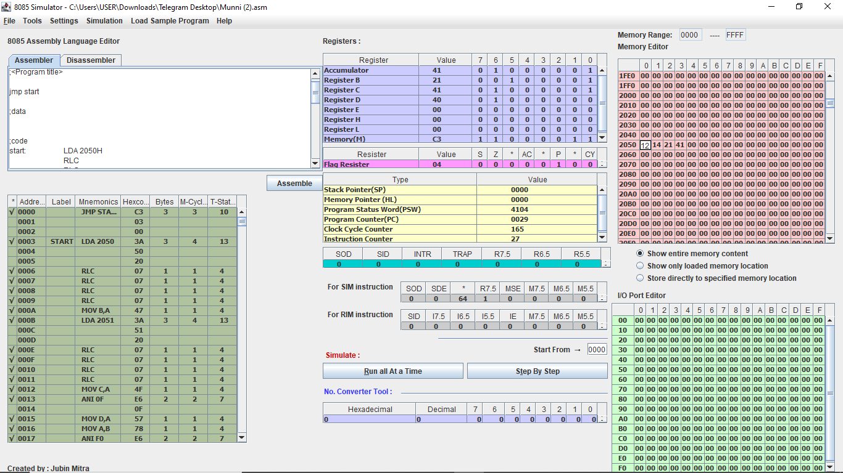

2. Two numbers A & B are stored in 2050 H and 2051 H , respectively . Write a program to perform A*B and store the results in 2052 H and 2053 H.

|  |  |  |  |  |  |
| --- | --- | --- | --- | --- | --- |
| **SL NO.** | **ADDRESS** | **OPCODE IN HEX CODE** | **LABEL** | **INSTRUCTIONS** | **COMMENTS** |
| 1 | 1000 | 21 |  | LXI H,0000 | Contents of memory location 0000 H into HL register pair |
| 1001 | 00 |
| 1002 | 00 |
| 2 | 1003 | 16 |  | MVI D,00 | Move immediate to D register |
| 1004 | 00 |
| 3 | 1005 | 3A |  | LDA 2051 H | Load accumulator direct memory location 2051 H  Get B |
| 1006 | 51 |
| 1007 | 20 |
| 4 | 1008 | FE |  | CPI 00 H | If B=0? |
| 1009 | 00 |
| 5 | 100A | 5F |  | MOV E,A | Move accumulator to E register  E=A |
| 6 | 100B | 3A |  | LDA 2050 H | Load accumulator direct memory location 2050H  Get A |
| 100C | 50 |
| 100D | 20 |
| 7 | 100E | FE |  | CPI 00 H | Is A=0? |
| 100F | 00 |
| 8 | 1010 | CA |  | JZ END | If A=0,nothing to do |
| 1011 | 18 |
| 1012 | 10 |
| 9 | 1013 | 19 | START | DAD D | HL + DE |
| 10 | 1014 | 3D |  | DCR A | Decrement the A |
| 11 | 1015 | C2 |  | JNZ START | If DE has not been added A times ,add again |
| 1016 | 13 |
| 1017 | 10 |
| 12 | 1018 | 22 | END | SHLD 2052 H | Store results as specified |
| 1019 | 52 |
| 101A | 20 |
| 13 | 101B | 76 |  | HLT | Stop the program |

Simulator with loaded machine code: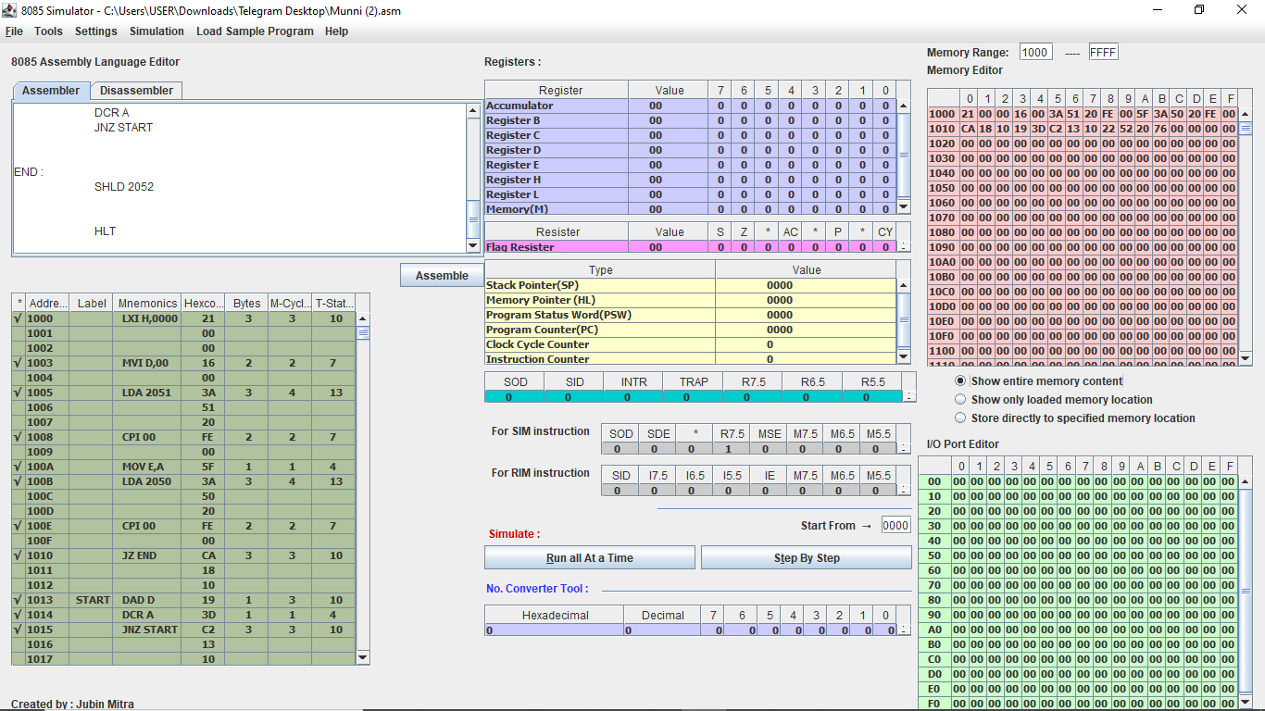

Sample input and output (A= M[2050 H]=12 H,B=M[2051 H]=12 H, A*B=144 H, M[2052 H]= 12 H, M[2053 H]=04 H).

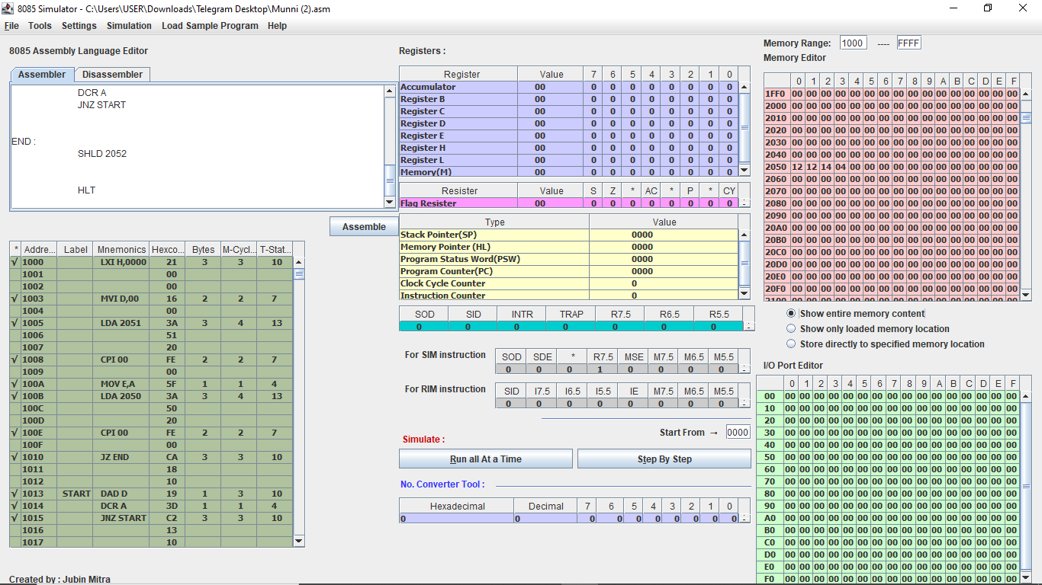

3.N numbers are stored in consecutive m/m location starting the from 2050 H. The value N is stored in 204F H.

I)Find maximum among the N numbers.

|  |  |  |  |  |  |
| --- | --- | --- | --- | --- | --- |
| **SL NO.** | **ADDRESS** | **OPCODE IN HEX CODE** | **LABEL** | **INSTRUCTIONS** | **COMMENTS** |
| 1 | 1000 | 3A |  | LDA 204F H | Load accumulator direct memory location 204F H  [A=N H] |
| 1001 | 4F |
| 1002 | 20 |
| 2 | 1003 | FE |  | CPI 00 H | Is N =0? |
| 1004 | 00 |
| 3 | 1005 | CA |  | JZ END | If N =0,nothing to do |
| 1006 | 1D |
| 1007 | 10 |
| 4 | 1008 | 4F |  | MOV C,A | Move accumulator to C register |
| 5 | 1009 | 21 |  | LXI 2050 H | Contents of memory location 2050 H into HL register pair |
| 100A | 50 |
| 100B | 20 |
| 6 | 100C | 46 |  | MOV B,M | Move memory address to B register B is current maximum number |
| 7 | 100D | 23 |  | INX H | Increase the HL register ,then go the next number |
| 8 | 100E | 0D |  | DCR C | Decrement the C register , then check the number |
| 9 | 100F | CA |  | JZ END | If end , nothing to do ,store this |
| 1010 | 1D |
| 1011 | 7E |
| 10 | 1012 | 7E | LOOP | MOV A,M | Move the memory address to accumulator |
| 11 | 1013 | B8 |  | CMP B | Compare against current maximum |
| 12 | 1014 | DA |  | JC SKIP | If B>A, do nothing |
| 1015 | 18 |
| 1016 | 10 |
| 13 | 1017 | 47 |  | MOV B,A | Move accumulator to B register load a new maximum |
| 14 | 1018 | 23 | SKIP | INX H | Increase the HL ,then go the next number |
| 15 | 1019 | 0D |  | DCR C | Decrement the C then check the number |
| 16 | 101A | C2 |  | JNZ LOOP | If numbers left, continue checking |
| 101B | 12 |
| 101C | 10 |
| 17 | 101D | 78 | END | MOV A,B | Move B register to accumulator [A=Maximum] |
| 18 | 101E | 32 |  | STA 204E H | Store the maximum |
| 101F | 4E |  |
| 1020 | 20 |  |
| 19 | 1021 | 76 |  | HLT | Stop the program |

Simulator with loaded machine code:

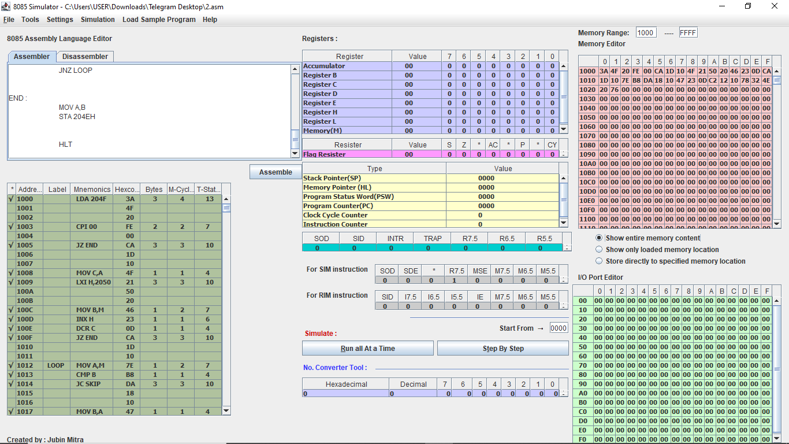

ii) Find the minimum among the N numbers.

We store the result (Minimum) in 204E H memory location.

|  |  |  |  |  |  |
| --- | --- | --- | --- | --- | --- |
| **SL NO.** | **ADDRESS** | **OPCODE IN HEX CODE** | **LABEL** | **INSTRUCTIONS** | **COMMENTS** |
| 1 | 1000 | 3A |  | LDA 204F H | Load accumulator direct memory location 204F H  [A=N H] |
| 1001 | 4F |
| 1002 | 20 |
| 2 | 1003 | FE |  | CPI 00 H | Is N=0? |
| 1004 | 00 |
| 3 | 1005 | CA |  | JZ END | If N =0,nothing to do |
| 1006 | 1D |
| 1007 | 10 |
| 4 | 1008 | 4F |  | MOV C,A | Move accumulator to C register |
| 5 | 1009 | 21 |  | LXI H ,2050 | Contents of memory location 2050 H into HL register pair |
| 100A | 50 |
| 100B | 20 |
| 6 | 100C | 46 |  | MOV B,M | Move memory address to B register , B is current minimum number |
| 7 | 100D | 23 |  | INX H | Increase the HL register ,then go the next number |
| 8 | 100E | 0D |  | DCR C | Decrement the C register ,then check the number |
| 9 | 100F | CA |  | JZ END | If end ,nothing to do ,store this |
| 1010 | 1D |
| 1011 | 10 |
| 10 | 1012 | 7E | LOOP | MOV A,M | Move the memory address to accumulator |
| 11 | 1013 | B8 |  | CMP B | Compare against current minimum |
| 12 | 1014 | DA |  | JC SKIP | If B>A, do nothing |
| 1015 | 18 |
| 1016 | 10 |
| 13 | 1017 | 47 |  | MOV B,A | Move accumulator to B register, load a new minimum |
| 14 | 1018 | 23 | SKIP | INX H | Increase the HL ,then go to the next number |
| 15 | 1019 | 0D |  | DCR C | Decrement the C register ,then check the number |
| 16 | 101A | C2 |  | JNZ LOOP | If numbers left, continue checking |
| 101B | 12 |
| 101C | 10 |
| 17 | 101D | 78 | END | MOV A, B | Move B register to accumulator [A=Minimum] |
| 18 | 101E | 32 |  | STA 204E H | Store the minimum |
| 101F | 4E |
| 1020 | 20 |
| 19 | 1021 | 76 |  | HLT | Stop the program |

Simulator with loaded machine code:

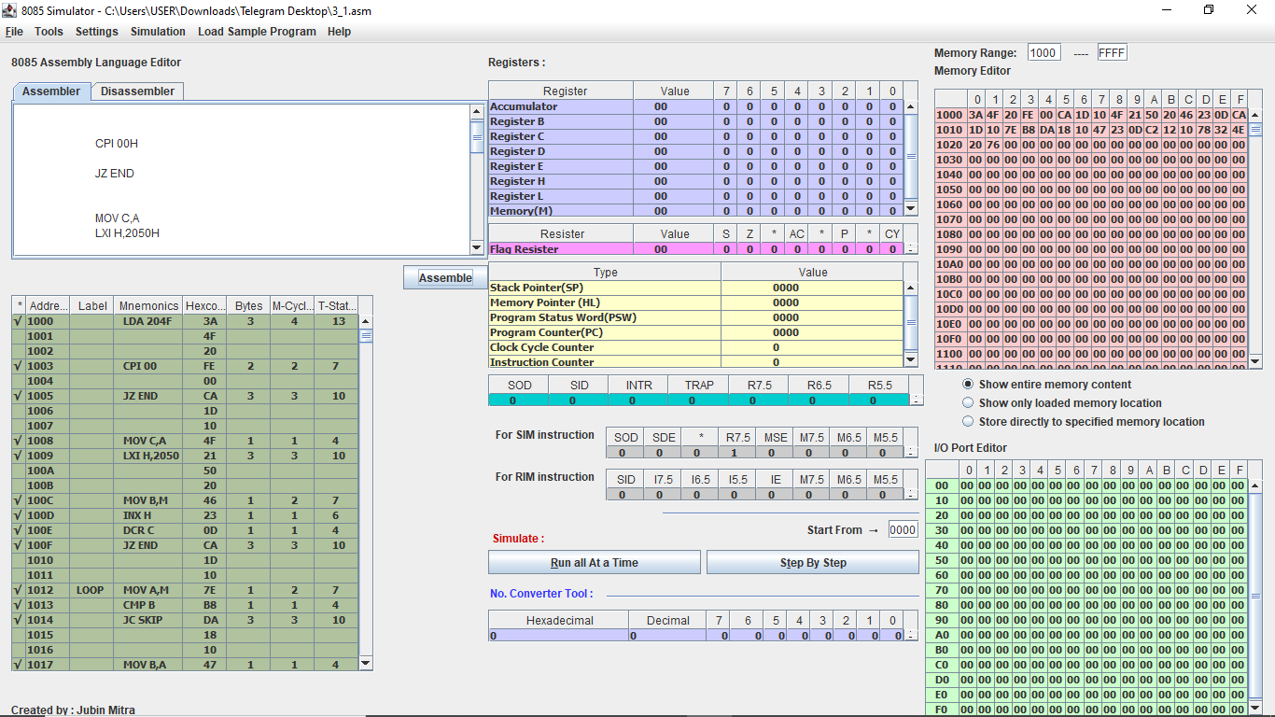

Sample input and output (M[204F H]=06 H, 6 numbers 6A,10,45,7E,B6, and DF,Starting from M[2050 H],

M[204E H]=10

iii)Sort the N numbers in ascending order.

We will be using bubble sort algorithm.

|  |  |  |  |  |  |
| --- | --- | --- | --- | --- | --- |
| **SL NO.** | **ADDRESS** | **OPCODE IN HEX CODE** | **LABEL** | **INTRUCTIONS** | **COMMENTS** |
| 1 | 1000 | 3A |  | LDA 204F H | Get N |
| 1001 | 4F |
| 1002 | 20 |
| 2 | 1003 | FE |  | CPI 00 H | Is N =? |
| 1004 | 00 |
| 3 | 1005 | CA |  | JZ END | Is N =0,nothing to do |
| 1006 | 25 |
| 1007 | 10 |
| 4 | 1008 | 57 |  | MOV D,A | D=outer loop counter |
| 5 | 1009 | 21 | OLOOP | LXI H ,2050 | Contents of memory location 2050 H into HL register pair |
| 100A | 50 |
| 100B | 20 |
| 6 | 100C | 4A |  | MOV C,D | C=inner loop counter |
| 7 | 100D | 0D |  | DCR C | Numbers of comparisons is 1 less than the length |
| 8 | 100E | CA |  | JZ END | If no comparisons are to be made ,do nothing |
| 100F | 25 |
| 1010 | 10 |
| 9 | 1011 | 7E | ILOOP | MOV A,M | Get first number |
| 10 | 1012 | 23 |  | INX H | Go to next number |
| 11 | 1013 | 46 |  | MOV B,M | Get second number |
| 12 | 1014 | 2B |  | DCX H | Go back to current position |
| 13 | 1015 | B8 |  | CMP B | Compare 2nd number against 1st number |
| 14 | 1016 | DA |  | JC SKIP | If 2nd number>1st number, do nothing |
| 1017 | 1D |
| 1018 | 10 |
| 15 | 1019 | 70 |  | MOV M,B | Put 2nd number first |
| 16 | 101A | 13 |  | INX H | Go to next location |
| 17 | 101B | 77 |  | MOV M,A | Put 1st number second |
| 18 | 101C | 2B |  | DCX H | Go back to previous location |
| 19 | 101D | 0D | SKIP | DCR C | Comparison done |
| 20 | 101E | C2 |  | JNZ ILOOP | Start from the next location |
| 101F | 11 |
| 1020 | 10 |
| 21 | 1021 | 15 |  | DCR D | One pass finished |
| 22 | 1022 | C2 |  | JNZ OLOOP | Go to the next pass |
| 1023 | 09 |  |
| 1024 | 10 |  |
| 23 | 1025 | 76 |  | HLT | Stop the program |

Simulator with loaded machine code:

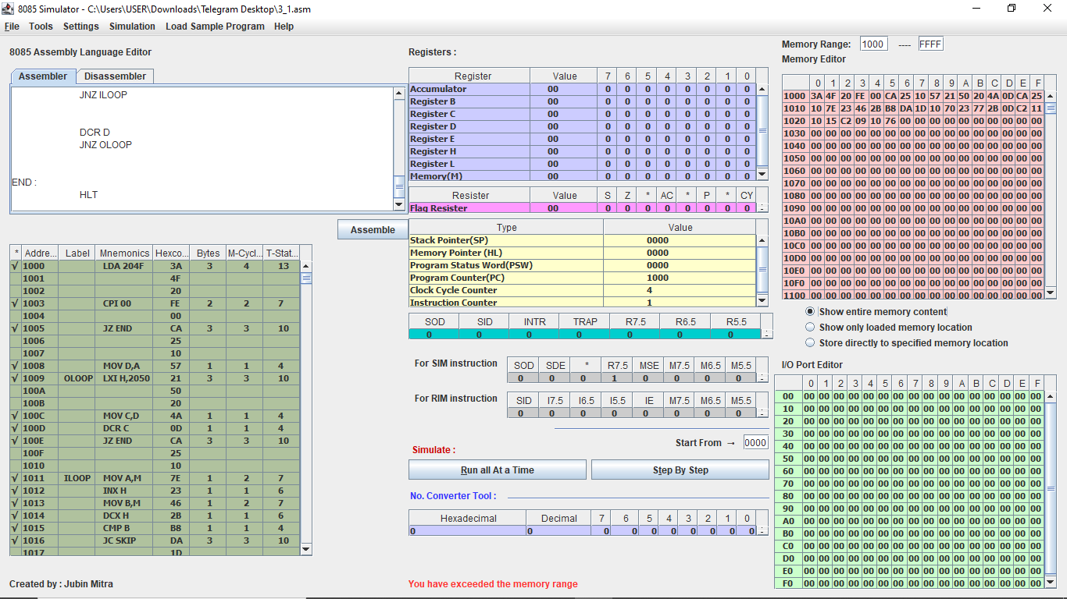

iv)Sort the N numbers in descending order.

We will be using bubble sort algorithm.

|  |  |  |  |  |  |
| --- | --- | --- | --- | --- | --- |
| **SL NO.** | **ADDRESS** | **OPCODE IN HEX CODE** | **LABEL** | **INTRUCTIONS** | **COMMENTS** |
| 1 | 1000 | 3A |  | LDA 204F H | Get N |
| 1001 | 4F |
| 1002 | 20 |
| 2 | 1003 | FE |  | CPI 00 H | Is N =? |
| 1004 | 00 |
| 3 | 1005 | CA |  | JZ END | Is N =0,nothing to do |
| 1006 | 25 |
| 1007 | 10 |
| 4 | 1008 | 57 |  | MOV D,A | D=outer loop counter |
| 5 | 1009 | 21 | OLOOP | LXI H ,2050 | Contents of memory location 2050 H into HL register pair |
| 100A | 50 |
| 100B | 20 |
| 6 | 100C | 4A |  | MOV C,D | C=inner loop counter |
| 7 | 100D | 0D |  | DCR C | Numbers of comparisons is 1 less than the length(D) |
| 8 | 100E | CA |  | JZ END | If no comparisons are to be made ,do nothing |
| 100F | 25 |
| 1010 | 10 |
| 9 | 1011 | 7E | ILOOP | MOV A,M | Get first number |
| 10 | 1012 | 23 |  | INX H | Go to next number |
| 11 | 1013 | 46 |  | MOV B,M | Get second number |
| 12 | 1014 | 2B |  | DCX H | Go back to current position |
| 13 | 1015 | B8 |  | CMP B | Compare 2nd number against 1st number |
| 14 | 1016 | DA |  | JC SKIP | If 2nd number<1st number, do nothing |
| 1017 | 1D |
| 1018 | 10 |
| 15 | 1019 | 70 |  | MOV M,B | Put 2nd number first |
| 16 | 101A | 13 |  | INX H | Go to next location |
| 17 | 101B | 77 |  | MOV M,A | Put 1st number second |
| 18 | 101C | 2B |  | DCX H | Go back to previous location |
| 19 | 101D | 0D | SKIP | DCR C | Comparison done |
| 20 | 101E | C2 |  | JNZ ILOOP | Start from the next location |
| 101F | 11 |
| 1020 | 10 |
| 21 | 1021 | 15 |  | DCR D | One pass finished |
| 22 | 1022 | C2 |  | JNZ OLOOP | Go to the next pass |
| 1023 | 09 |  |
| 1024 | 10 |  |
| 23 | 1025 | 76 |  | HLT | Stop the program |

Simulator with loaded machine code:



4.N numbers are stored in consecutive m/m location startingfrom 2050 H. The value N is stored in 204F H. Write a program to copy the even and odd numbers starting from 2100 H and 2200 H ,respectively. Store the total num of even and odd numbers in 2300 H and 2301 H , respectively

|  |  |  |  |  |  |
| --- | --- | --- | --- | --- | --- |
| **SL NO.** | **ADDRESS** | **OPCODE IN HEX CODE** | **LABEL** | **INSTRUCTIONS** | **COMMENTS** |
| 1 | 1000 | 01 |  | LXI B , 2100 | Starting address of even numbers |
| 1001 | 00 |
| 1002 | 21 |
| 2 | 1003 | 11 |  | LXI D,2200 | Starting address of odd numbers |
| 1004 | 00 |
| 1005 | 22 |
| 3 | 1006 | 3A |  | LDA 204F | Get N |
| 1007 | 4F |
| 1008 | 20 |
| 4 | 1009 | FE |  | CPI 00 H | Is N =0? |
| 100A | 00 |
| 5 | 100B | CA |  | JZ END | If N=0, nothing to do |
|  | 100C | 27 |  |  |  |
| 100D | 10 |
| 6 | 100E | 21 |  | LXI H ,2050 | Contents of memory location 2050 H into HL register pair/input |
| 100F | 50 |
| 1010 | 20 |
| 7 | 1011 | 7E | LOOP | MOV A, M | Get current numbers |
| 8 | 1012 | E6 |  | ANI 01 | Check odd or not |
| 1013 | 01 |
| 9 | 1014 | 7E |  | MOV A, M | Restore the number |
| 10 | 1015 | CA |  | JZ EVEN | If 0, then even |
| 1016 | 1A |
| 1017 | 10 |
| 11 | 1018 | 12 |  | STAX D | This is an odd number |
| 12 | 1019 | 13 |  | INX D | One odd number added |
| 13 | 101A | 02 | EVEN | STAX B | This is an even number |
| 14 | 101B | 03 |  | INX B | One even number added |
| 15 | 101C | 23 | LEND | INX H | Go to the next address |
| 16 | 101D | 3A |  | LDA 204F | Get n |
| 101E | 4F |
| 101F | 20 |
| 17 | 1020 | 3D |  | DCR A | One number checked |
| 18 | 1021 | 32 |  | STA 204F | Store N for later use |
| 1022 | 4F |
| 1023 | 20 |
| 19 | 1024 | C2 |  | JNZ LOOP | If numbers left ,continue |
| 1025 | 11 |
| 1026 | 10 |
| 20 | 1027 | 79 | END | MOV A,C | A=C=number of even number because BC started from 2100 H |
| 21 | 1028 | 32 |  | STA 2300 H | Store numbers of even number |
| 1029 | 00 |
| 102A | 23 |
| 22 | 102B | 7B |  | MOV A,E | A=E=number of odd numbers because DE started from 2200 H |
| 23 | 102C | 32 |  | STA 2301 H | Store number of odd numbers |
| 102D | 01 |
| 102E | 23 |
| 24 | 102F | 76 |  | HLT | Stop the program |

Simulator with loaded machine code:

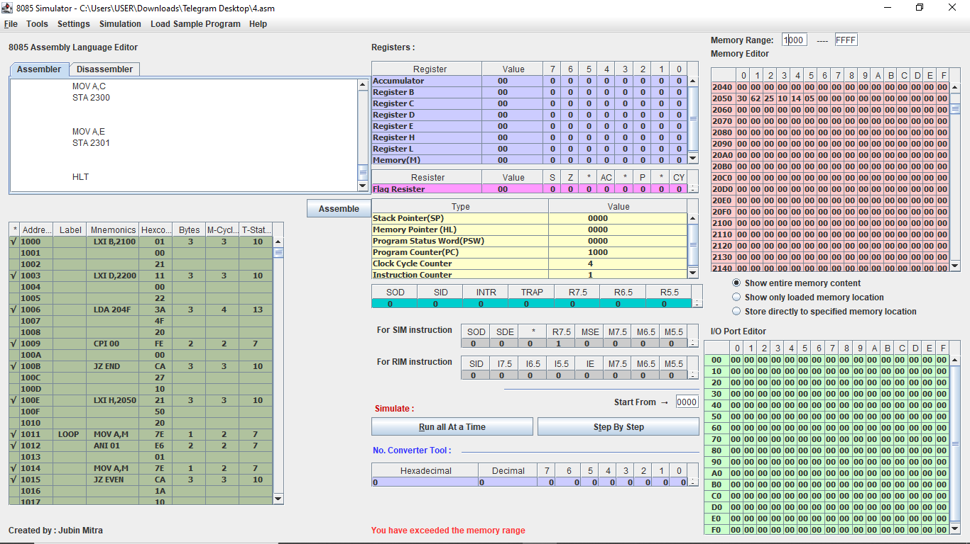

Sample input (M[204F H]=06 H, 6 numbers 30 H,62 H,25 H,10 H,24 H and 05 H starting from M[2050 H]):

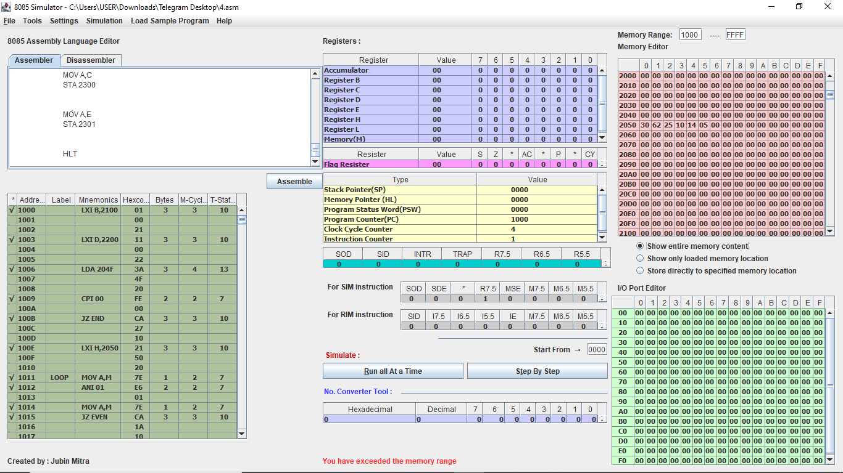

Sample output (2 even numbers 30 H, 62 H starting from M[2100 H], 3 odd numbers 25 H,05 H, 07 H starting from M[2200 H], M[2300 H]=02 H,M[2301]=03 H):

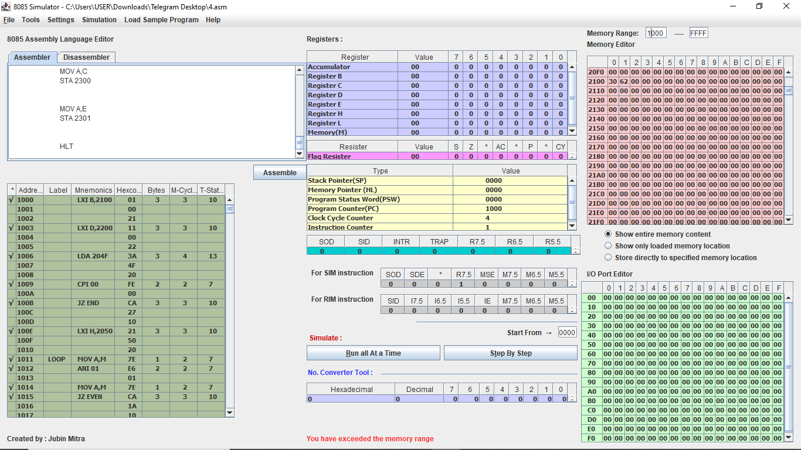 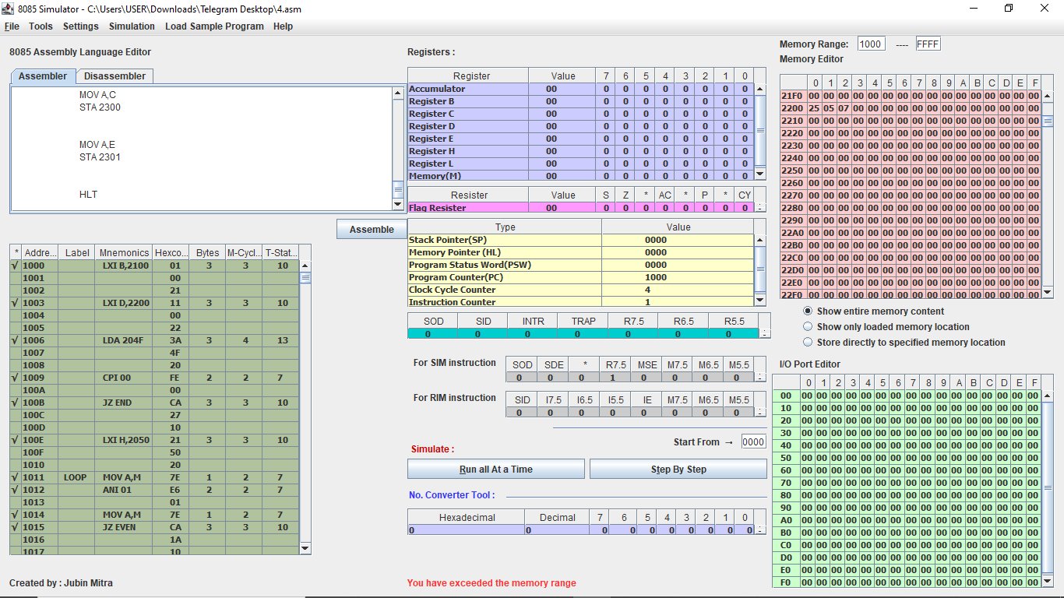 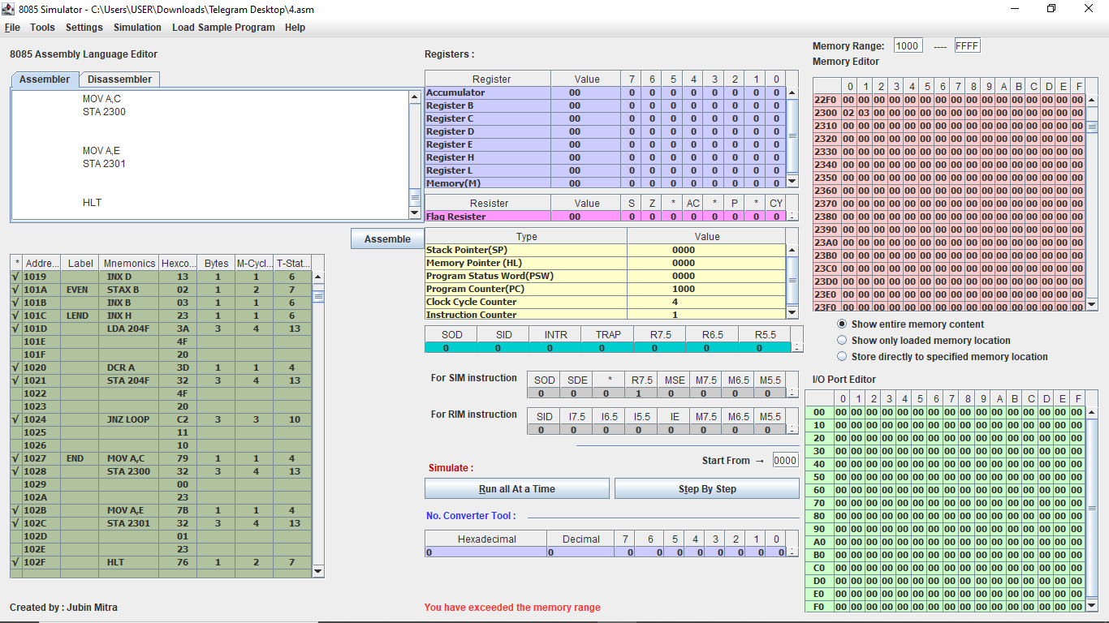

5. N numbers are stored in consecutive m/m location starting from 2050 H. The value N is stored in 204F H. Write a program to test whether a number stored in 204E H is present in the list. If present , store its position in the list at 204D H ;otherwise store FF H.

We will give position by a zero – based index.

|  |  |  |  |  |  |
| --- | --- | --- | --- | --- | --- |
| **SL NO.** | **ADDRESS** | **OPCODE IN HEX CODE** | **LABEL** | **INSTRUCTIONS** | **COMMENTS** |
| 1 | 1000 | 21 |  | LXI H, 204E | B=Numbers to search (key) |
| 1001 | 4E |
| 1002 | 20 |
| 2 | 1003 | 46 |  | MOV B,M | Move memory location to B register |
| 3 | 1004 | 23 |  | INX H | HL=204F H |
| 4 | 1005 | 7E |  | MOV A,M | Get N |
| 5 | 1006 | FE |  | CPI 00 H | Is N=0? |
| 1007 | 00 |
| 6 | 1008 | CA |  | JZ END | If N=0,do not search |
| 1009 | 1E |
| 100A | 10 |
| 7 | 100B | 4F |  | MOV C,A | Move accumulator to C register [C=A=Counter] |
| 8 | 100C | 51 |  | MOV D,C | Move C register to D register[D=total no of items] |
| 9 | 100D | 23 |  | INX H | HL=2050 H=Starting address of input |
| 10 | 100E | 7E | LOOP | MOV A,M | Move memory address to accumulator, load current number |
| 11 | 100F | B8 |  | CMP B | Compare against key |
| 12 | 1010 | C2 |  | JNZ CONT | If unequal ,continue loop |
| 1011 | 19 |
| 1012 | 10 |
| 13 | 1013 | 7A |  | MOV A,D | A=D=Totals number of items |
| 14 | 1014 | 91 |  | SUB C | A=position of key in list |
| 15 | 1015 | 32 |  | STA 204D | Store found position |
| 1016 | 4D |
| 1017 | 20 |
| 16 | 1018 | 76 |  | HLT | We have nothing to do anymore |
| 17 | 1019 | 23 |  | INX H | Go to next number |
| 18 | 101A | 0D |  | DCR C | Checked one number |
| 19 | 101B | C2 |  | JNZ LOOP | If number left,continue |
| 101C | 0E |
| 101D | 10 |
| 20 | 101E | 3E | END | MVI A,FF | We haven’t found key |
| 101F | FF |
| 21 | 1020 | 32 |  | STA 204D | Store the number |
| 1021 | 4D |
| 1022 | 20 |
| 22 | 1023 | 76 |  | HLT | Stop the program. |

Simulator with loaded machine code:

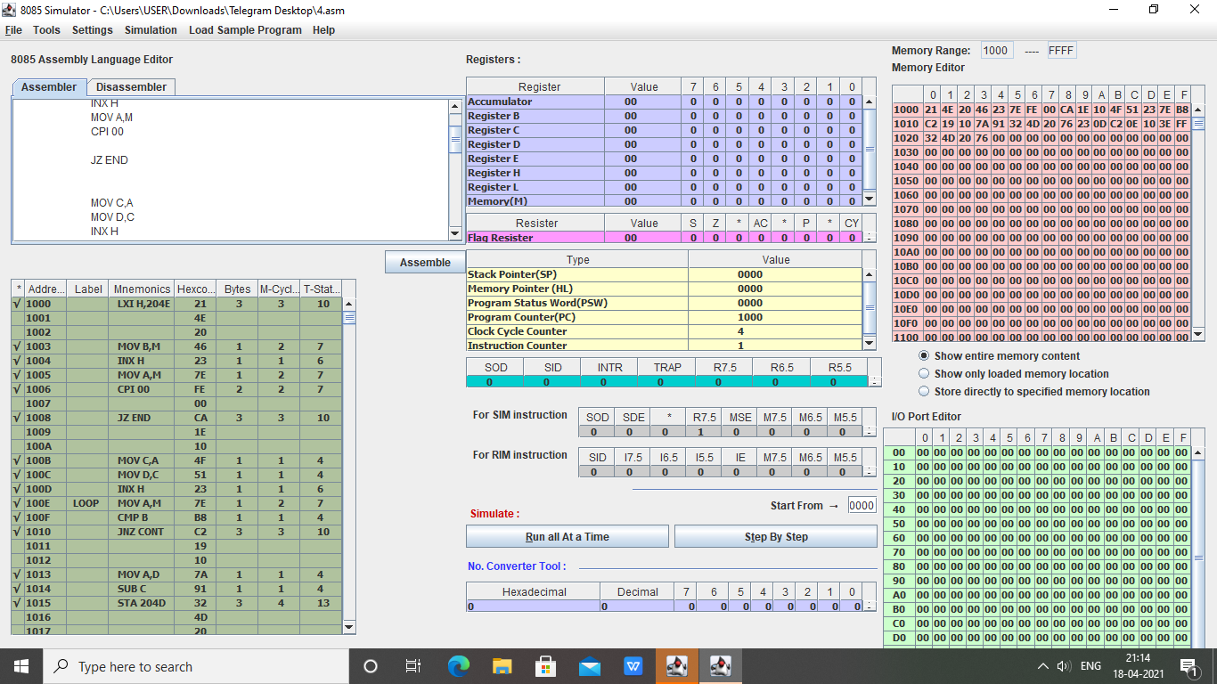

NAME : **Sujan Biswas**

BATCH: BSCE 2ND year , (LATERAL)

ROLL NO : 302010501003

Microprocessor lab Assignment problem sheet #3

**Problem 1:** A set of N data bytes is stored in m/m locations starting from 2501H. The value of N is stored in 2500H. Write a program to store these data bytes from m/m location 2600H if D0

or D7 is 1; otherwise reject the data byte.

# Solution:

SL NO

ADDRESS

LABLE

INSTRUCTION

OPCODE IN HEX

COMMENTS

1.

0000

LXI H, 2600 21

HL = 2600

2.

0001

00

3.

0002

26

4.

0003

XCHG

EB

swap(DE, HL)

5.

0004

LXI H, 2500 21

Now HL = 2500

6.

0005

00

7.

0006

25

8.

0007

MOV B, M

46

B = M[2500]

9.

0008

LOOP

INX H

23

HL = HL + 1

10.

0009

MOV A, M

7E

contents of the memory stored into the accumulator

11.

000A

RRC

0F

rotate the content of the accumulator by the affecting the conditions of the Carry Bit

12.

000B

JNC COND2 D2

If no carry is generated then jump to condition 2

13. 000C 16

14.

000D

00

15.

000E

RLC

07

rotate the contents of the accumulator to the left to restore the number back

16.

000F

XCHG

EB

SWAP(HL, DE)

17.

18.

19.

20.

21.

22.

23.

24.

25.

26.

27.

28.

29.

30.

31.

32.

33.

34.

35.

36.

36.

0010

0011

0012

0013

0014

0015

0016

0017

0018

0019

001A

001B

001C

001D

001E

001F

0020

0021

0022

0023

0024

COND2

SKIP

MOV M, A 77

INX H 23

XCHG EB

JMP SKIP C3 20

00

RLC 07

RLC 07

JNC SKIP D2 20

00

RRC 0F

XCHG EB

MOV M, A 77

INX H 23

XCHG EB

DCR B 05

JNZ LOOP C2 08

00

HLT 76

contents of the HL register pair in A

HL = HL + 1 SWAP(DE, HL)

if condition 1 satisfied no need to check condition 2

rotate the contents of the accumulator to restore the number

check the D7 bit

if the second condition also fails jump to skip

rotate the accumulator right to retrieve the number back

SWAP(DE, HL) M = A;

HL = HL + 1 SWAP(DE, HL)

decrement the loop counter

continue till no numbers are left

stop all operations

Sample input and output(M[2500 H ] = N = 05 H , 5 numbers 76 H , 73 H , 02 H , DF H and EE H starting from M[2501 H ], 3 numbers 73 H , DF H and EE H starting from M[2600 H ]):

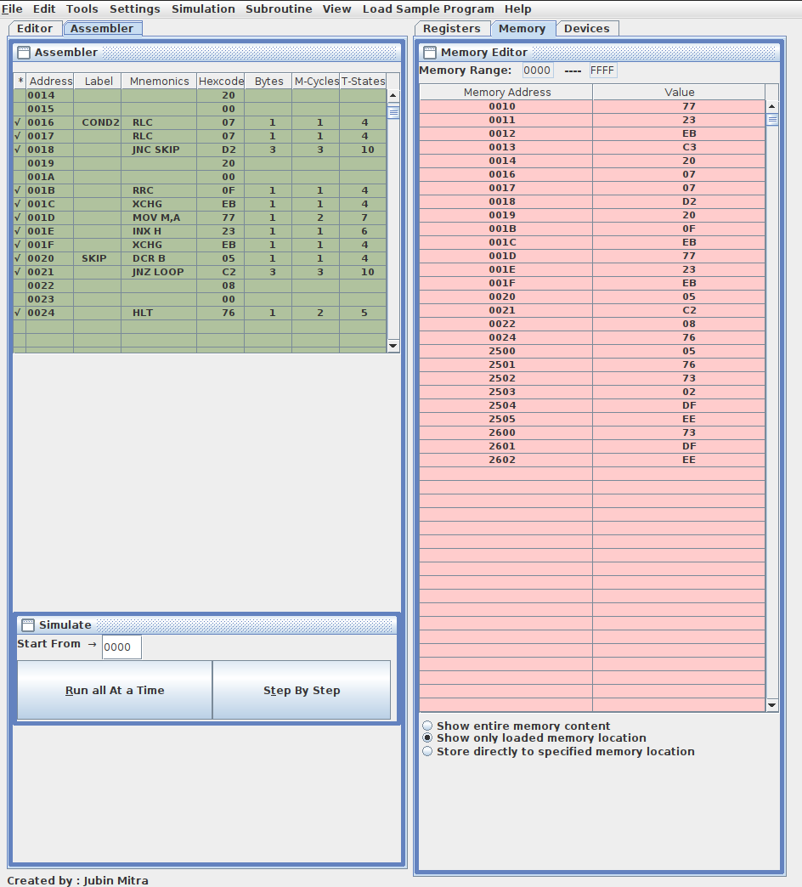

**Problem 2:** There are N data bytes stored from m/m location 2200H. The value of N is stored in 21FFH. Write an 8085 program to find the sum of integers whose LSB and MSB are 1.

Store the result in 2500H and 2501H. Solution:

SL NO

1.

2.

3.

4.

5.

6.

7.

8.

9.

10.

11.

12.

13.

14.

15.

16.

17.

18.

19.

20.

21.

22.

23.

24.

ADDRESS

0000

0001

0002

0003

0004

0005

0006

0007

0008

0009

000A

000B

000C

000D

000E

000F

0010

0011

0012

0013

0014

0015

0016

0017

Label

LOOP

Instruction (Mnemonics)

LXI H, 21FF

MOV B, M LXI H, 2200

MVI C, 00

MVI A, 00

STA 2600

MOV A, M

ANI 81

CPI 81

JNZ SKIP1

LDA 2600

Opcode in Hex

21

FF 21

46

21

00

22

0E

00

3E

00

32

00

26

7E

E6 81 FE 81 C2 21

00

3A

00

COMMENT HL = 21FF

B = M

HL = 2200

C = 0

A = 0

A = M[2600]

A = contents of memory specified by HL register pair

A = A & (1000 0001) to

check if lsb and msb is one or not

compare to check D7 and D0 is one or not

if not satisfied move to skip

A = contents of memory location 2600 used as dummy m/m

25.

26.

27.

28.

29.

30.

31.

32.

33.

34.

35.

36.

37.

38.

39.

40.

41.

42.

43.

44.

45.

46.

47.

48.

49.

50.

0018

0019

001A

001B

001C

001D

001E

001F

0020

0021

0022

0023

0024

0025

0026

0027

0028

0029

002A

002B

002C

002D

002E

002F

0030

0031

SKIP1

SKIP

LAST

26

ADD M 86

JNC SKIP D2 2C

00

INR C 0C

JMP SKIP C3 2C

00

LDA 2600 3A

00

26

INX H 23

DCR B 05

JNZ LOOP C2 0B

00

JMP LAST C3 31

00

INX H 23

DCR B 05

JNZ LOOP C2 0B

00

STA 2500 32

if condition is satisfied perform addition

Ig no carry is present move to skip

increment the carry move to skip

A = contents of memory location 2600 used as dummy m/m

HL = HL + 1 B = B - 1

continue till last number

no number present the jump to last

HL = HL + 1 B = B - 1

continue till last number

store the sum in m/m 2500

51.

0032

00

52.

0033

25

53.

0034

MOV A, C

79

move the carry

54.

0035

STA 2501

32

store the MSB in m/m 2501

55. 0036 01

56.

0037

25

57.

0038

HLT

76

stop all operations

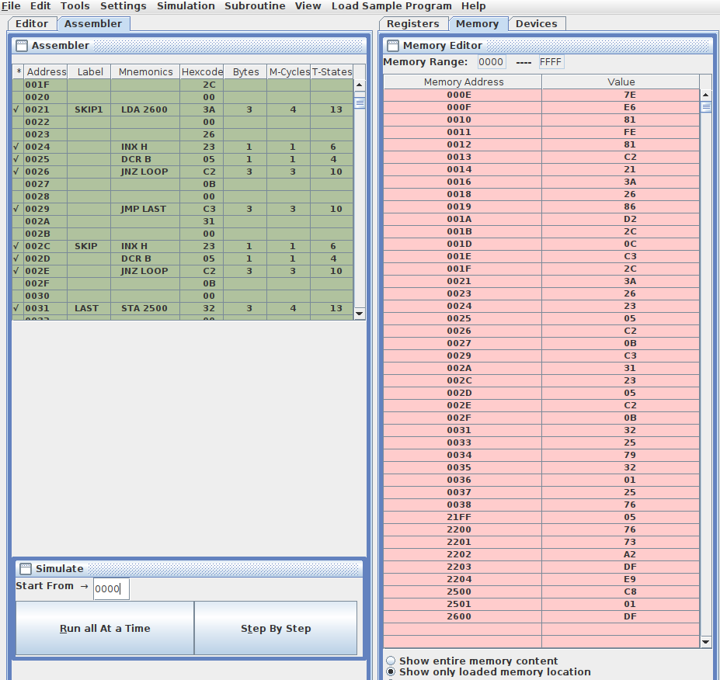Sample input and output(M[21FF H ] = N = 05 H , 5 numbers 76 H , 73 H , A2 H , DF H and E9 H starting from M[2501 H ], M[2500 H ] = C8 H , M[2501 H ] = 01 H , DF H + E9 H = 1C8 H ):

**Problem 3:** Write an 8085 program to generate Nth fibonacci number using function and store it in 2050H. The value of N (8-bits) is stored in memory 2060H.

# Solution :-

SL NO

1.

2.

3.

4.

5.

6.

7.

8.

9.

10.

11.

12.

13.

14.

15.

16.

17.

18.

19.

20.

21.

Address

0000

0001

0002

0003

0004

0005

0006

0007

0008

0009

000A

000B

000C

000D

000E

000F

0010

0011

0012

0013

0014

Label

LOOP

Instruction (Mnemonics)

LXI H, 2060

MOV B, M MVI D, 00

MVI E, 01

DCR B MVI A, 00

CALL FUNC

DCR B JNZ LOOP

STA 2050

Opcode in Hex

21

60

20

46

16

00

1E

01

05

3E

00

CD 16

00

05

C2 09

00

32

50

20

COMMENTS

Load the value of N in HL register pair

B = N

initialise the value of D with zero

initialise the value of the register E with 1

B = B - 1

initialise the accumulator with zero value

make a call to the function to evaluate the fibonacci number

B = B - 1

continue till nth fibonacci is not evaluated

store the contents of the accumulator in the m/m location 2050

22.

0015

HLT

76

Stop all operations

23.

0016

FUNC

ADD D

82

A = A + D

24.

0017

ADD E

83

A = A + E

25.

0018

MOV D, E

53

D = E

26.

0019

MOV E, A

5F

E = A

27.

001A

RET

C9

return back to the statement where function call was made

Sample input and output(M[2060 H ] = N = 0A H = 10 10 , M[2050 H ] = FIB(0A H ) = 37 H = 55 10 ):

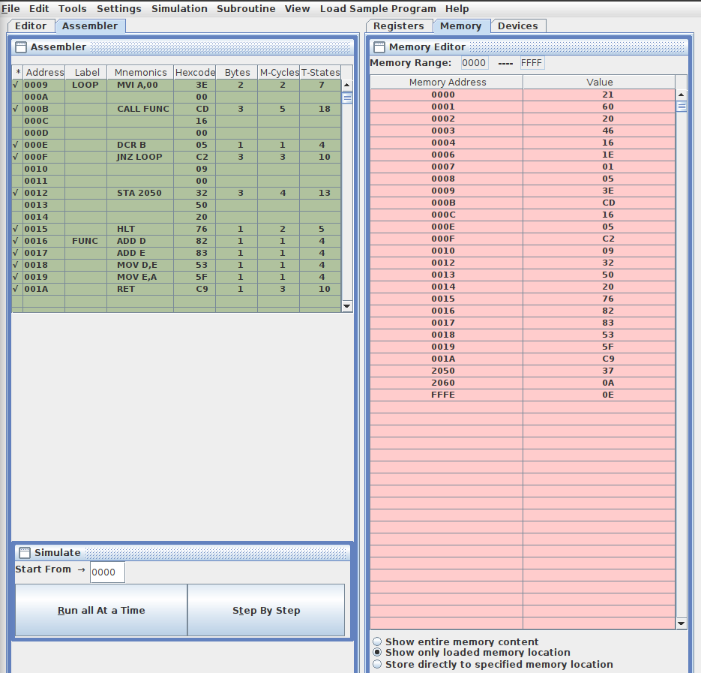

**Problem 4:** Write a program to transfer a block of bytes of size N from location1 to location2 (location2 > location1) when the size of overlap between the two locations is defined by

M. The values of N and M are stored in 201EH and 201FH, respectively.

# Solution :-

SL NO

1.

2.

3.

4.

5.

6.

7.

8.

9.

10.

11.

12.

13.

14.

15.

16.

17.

18.

19.

20.

Address

0000

0001

0002

0003

0004

0005

0006

0007

0008

0009

000A

000B

000C

000D

000E

000F

0010

0011

0012

0013

Label

Instruction (Mnemonics)

LDA 201E

CPI 00

JZ END

LDA 201E

MOV C, A LXI H, 201F

MOV B, M SUB B

JZ END

Opcode in Hex

3A

1E

20

FE

00

CA 33

00

3A

1E

20

4F

21

1F

20

46

90

CA 33

00

COMMENT

A= N

compare the contents of the accumulator with zero

If N == 0 no need to perform any operation

A = N

C = A

store the m/m location where the overlapping size is present

B = M

A = A - B

if N - M == 0 we need to perform no operation

21.

22.

23.

24.

25.

26.

27.

28.

29.

30.

31.

32.

33.

34.

35.

36.

37.

38.

39.

40.

41.

42.

43.

44.

45.

0014

0015

0016

0017

0018

0019

001A

001B

001C

001D

001E

001F

0020

0021

0022

0023

0024

0025

0026

0027

0028

0029

002A

002B

002C

LOOP

JC END DA 33

00

MOV E, A 5F

LHLD 2020 21

20

20

MVI D, 00 16

00

DAD D 19

XCHG EB

LHLD 2020 2A

20

20

DCR C 0D

MVI B, 00 06

00

DAD B 09

XCHG EB

DAD B 09

INR C 0C

XCHG EB

MOV A, M 7E

XCHG EB

MOV M, A 7E

if N - M < 0 , it’s an invalid input

E = N - M

HL = location1

DE = N - M

HL = location1 + (N - M) DE = location1 + (N - M) HL = location1

C = N - 1 BC = N - 1

HL = end of location1 DE = end of location1 HL = end of location2 C = N

SWAP(DE, HL)

contents moved into accumulator

SWAP(DE, HL)

store the contents into desired memory location from backwards

46.

002D

DCX H

2B

HL = HL - 1

47.

002E

DCX D

1B

DE = DE - 1

48.

002F

DCR C

0D

decrement the value of loop counter

49.

0030

JNZ LOOP

C2

continue till a single element is left to transfer

50. 0031 29

51.

0032

00

52.

0033

END

HLT

76

stop all operations

Sample input(M[201E H ] = 05 H , M[201F H ] = 03 H , M[2020 H ] = 30 H , M[2021 H ] = 20 H ,

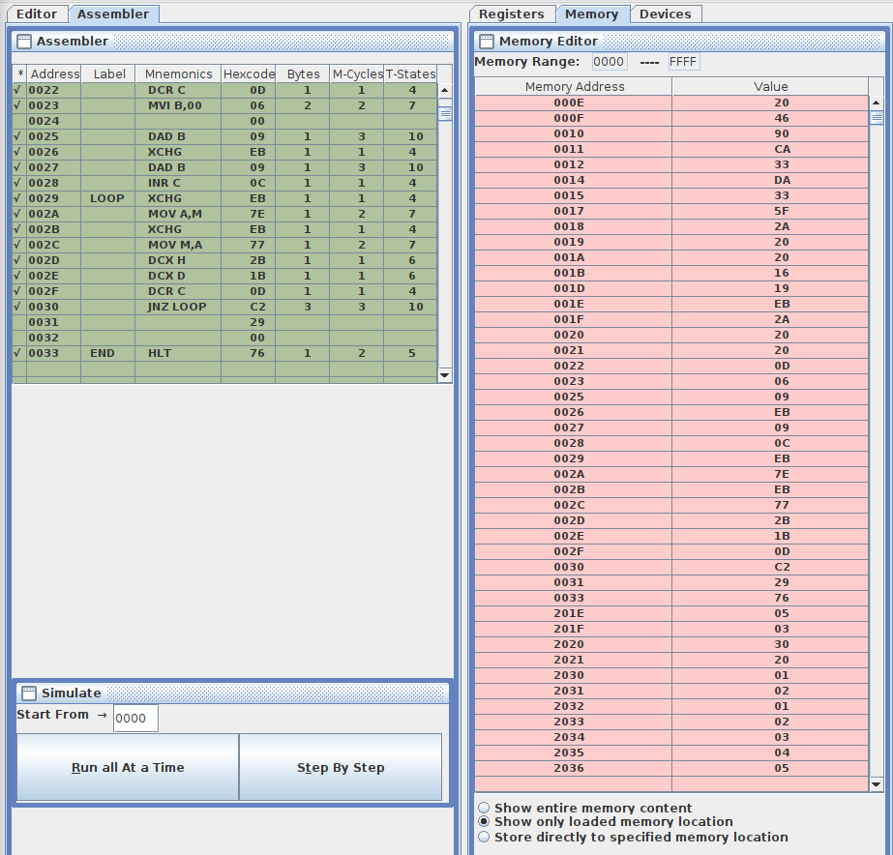location1 = 2030 H , location2 = 2032 H , 5 numbers 0A H , 0B H , 0C H , 0D H and 0E H starting from M[2030 H ]):